

**1、课程性质及主要内容**

**2、学习重难点**

**3、学习方法指引**

**4、考核方式**

**5、试题分析**

**6、老师联系方式**

**课程性质及主要内容**

1.课程性质

“管理英语3”是为国家开放大学管理类专业（专科起点本科）开设的公共英语课程；计3学分，54学时，开设一学期，建议第一学期开设。本课程将英语学习与行政管理、公共事业管理、教育管理、工商管理、农村行政管理等专业的职场活动相结合，以真实的语言素材为载体创设职场情景，在进行英语语言基础知识和基本技能训练的同时，培养学生在职场情景下使用英语进行交流的能力。

2.课程任务

通过“管理英语3”课程的学习，学生应能掌握一定英语语言基础知识和基本技能，具有一定的读、听、说、写能力；同时，了解管理活动中最基本的英语词语及表达方式，能在涉及与行政管理、公共事业管理、教育管理、工商管理、农村行政管理等专业的职场活动中进行基本交流；并为今后职场英语应用能力的进一步提高奠定基础。

3.教学对象

“管理英语3”课程的教学对象为国家开放大学管理类的行政管理、公共事业管理、教育管理、工商管理、农村行政管理等专业的成人学生和具有同等英语水平的业余学习者。

4.课程衔接

“管理英语3” 的前导课程有“管理英语1”，“管理英语2”，后续课程有“管理英语4”。

**课程学习基本要求**

“管理英语3”课程在加强学生的英语语言基础知识和基本技能训练的同时，使学生接触并了解与职业相关的基本知识，培养学生在管理活动中使用英语进行交际的实际能力。本课程不同维度的基本要求如下：

1.语言基础知识

● 在词汇认知方面，应能认知3,200个左右的词汇（含前期认知的2,600个左右）及其常见短语或固定搭配，以及一定量的职场相关词汇和短语；

● 在词汇掌握方面，应能熟练使用其中的2,000个左右词汇（含前期掌握的1,600个左右）及其常见短语或固定搭配，以及一定量的职场相关词汇和短语；

● 在语法知识方面，应能基本掌握基础语法知识（见附录1）；

● 在功能意念方面，应能熟悉常见功能意念（见附录2）及其惯用表达方法等。

● 在听力方面，应能基本听懂发音清楚、语速接近正常的日常生活和管理活动中的常见对话或其他素材，能够获取对话的主旨要义和具体事实性信息；

● 在口语方面，能就日常话题和管理事务情景话题进行一般性交谈，交流基本顺畅；

● 在阅读方面，能够基本读懂所学词汇和语法范围内的短文，能够基本读懂与职场工作密切相关的语言素材，如机构介绍招聘广告、财务预算报告、附信、通知等应用文体素材；能够理解阅读内容的主旨要义、具体信息；能够根据上下文推测生词词义，基本推断作者的意图、观点或态度；

● 在写作方面，能够基本完成指定话题和内容的短文写作，能够进行日常生活和职场相关的一般性应用文写作（如单位介绍、投诉信、简报、质量证明、申请表、发票、工作简报、招聘广告等），格式符合规范，语句基本正确，语义基本连贯；

● 在翻译方面，能借助词典将日常生活题材或管理活动中常见英语资料译成汉语，译文基本达意，表述基本恰当，行文基本通顺。汉译英要求略低于此。

3.职业技能素养

通过职场环境下的英语语言知识的学习以及英语交流技能的训练，学生应能够参与职业环境中常见的口头和书面交流活动；能够合理运用所学语言知识和技能，模仿所学内容参与一般的管理情景活动；能够在职业环境中使用有效的英语学习方法，增强英语自主学习能力，提高职场环境中的英语语言技能素养。

**课程学习内容**

本课程分为八个学习单元。每个学习单元都是职场学习情境，通过学习单元的学习，你能够掌握特定的语言功能、语法结构，了解相应的职场情景文化和点滴。 [【查看详细】](http://oss.ouchn.cn/ddzx/N601/waiyu/glyy3/pdf/zmx.pdf)

**学习重难点**

**（1）主要学习任务模块**

•Guidance（学习引导）：列举本单元的主要学习任务、学习目标。

•Listening and Speaking（听说活动）：包括两段对话，并结合对话内容提供教师讲解、练习活动，使听、说训练相结合。

•Reading（阅读活动）：包括两个阅读训练，并结合相应内容提供教师讲解及练习活动。

•Writing（写作活动）：为写作训练。

•Self-test（单元测试）：形考任务，均为即时反馈型自测题。

**（2）助学、导学模块**

•Useful Expressions（常用语句）：针对单元话题或语言功能，提供常见用语或句式，供你拓展练习之用。

•Check It Out（语法提示）：从本单元语料中选取语法项目，对语法点进行简单提示，非系统学习。

•Culture Note（文化点滴）：旨在进行知识拓展，非考核内容。

•Workplace Tip（职场点滴）：职场相关小知识点的提示。

•Language Notes（语言注解）：位于各学习模块中，重点讲解语料中的语言点、固定用法、习语、词组、文化现象等，帮助你理解语料。

**学习方法指引**



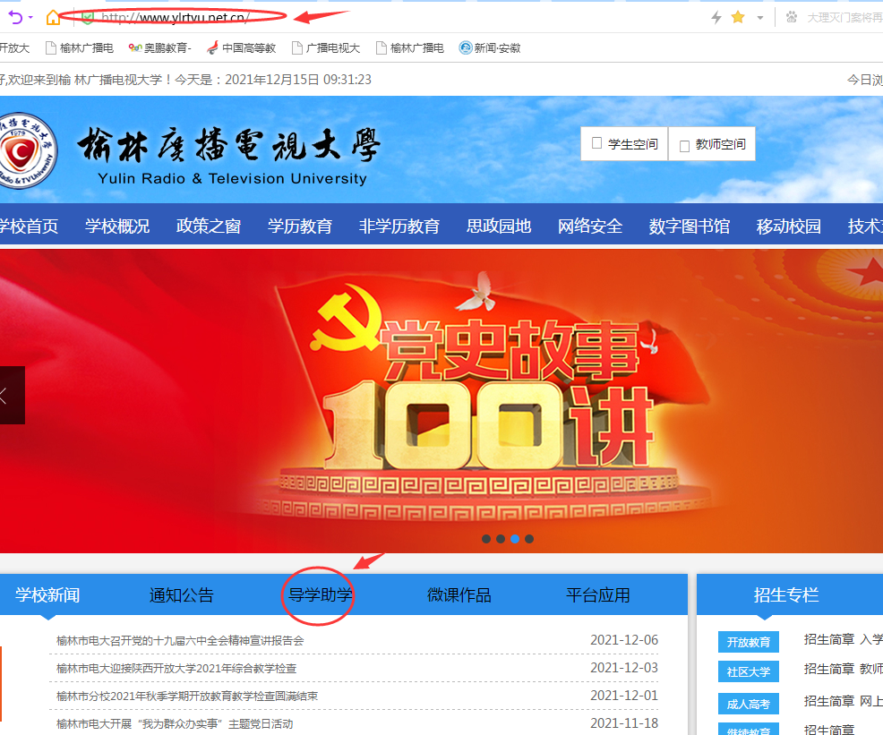





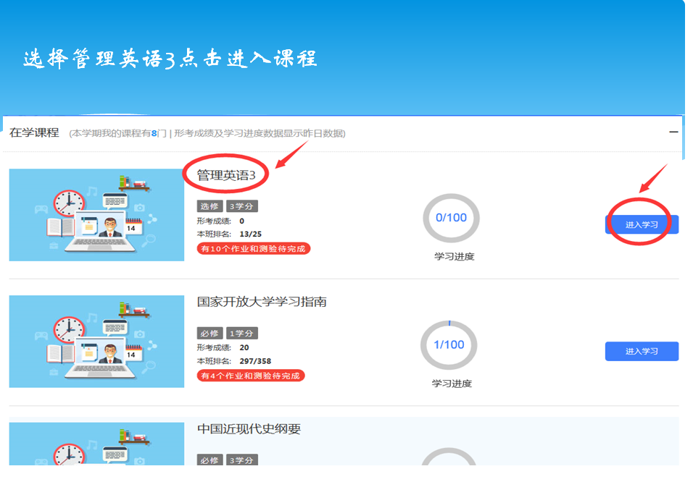

密码Ouchn19870523

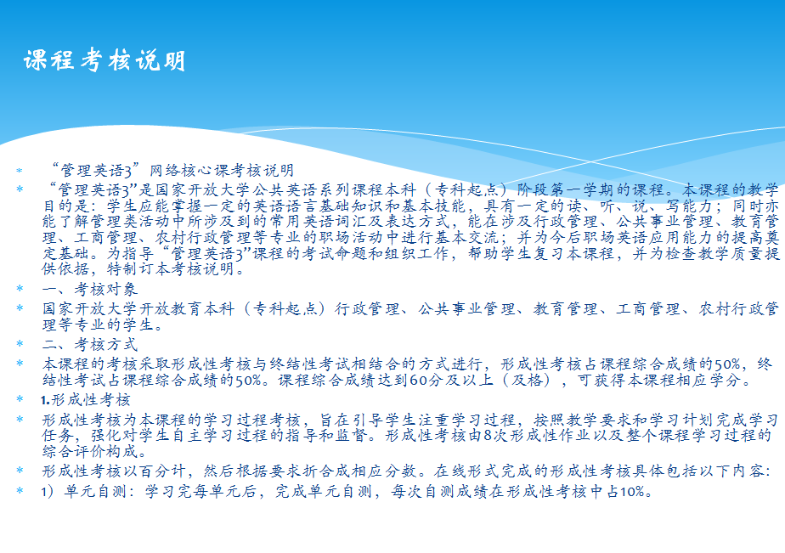

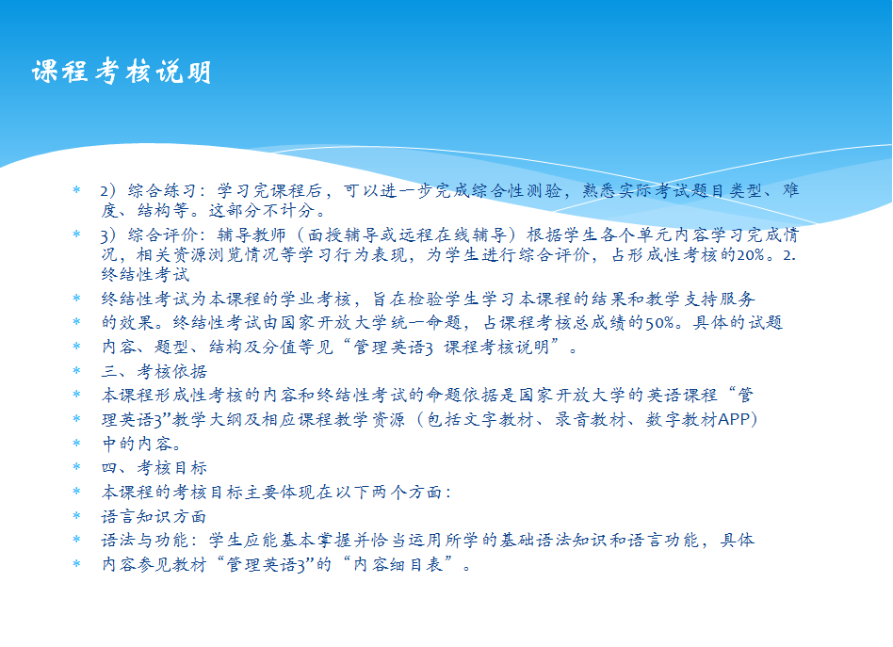

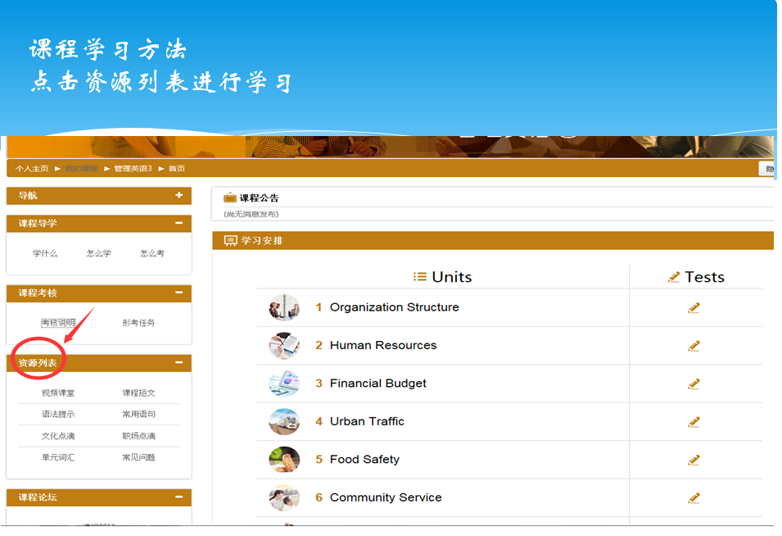

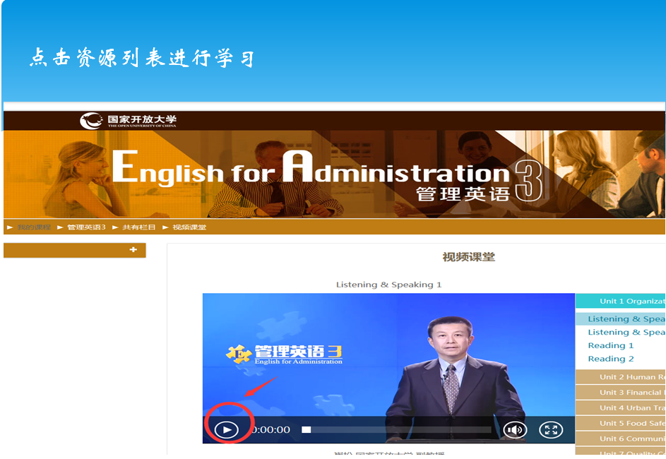

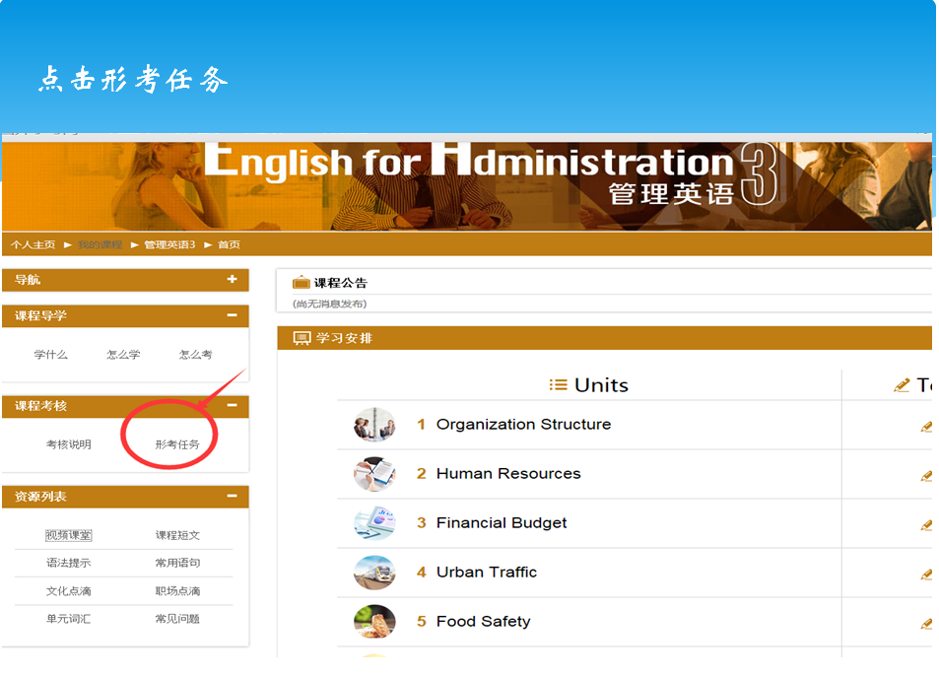

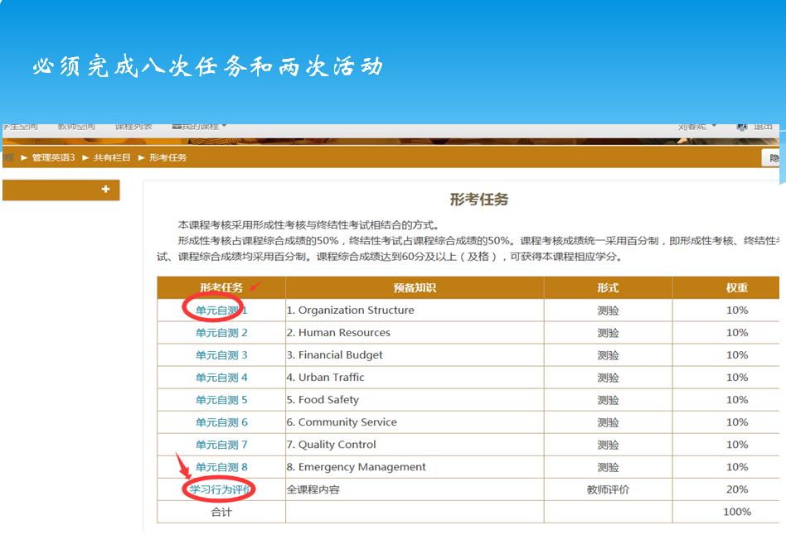

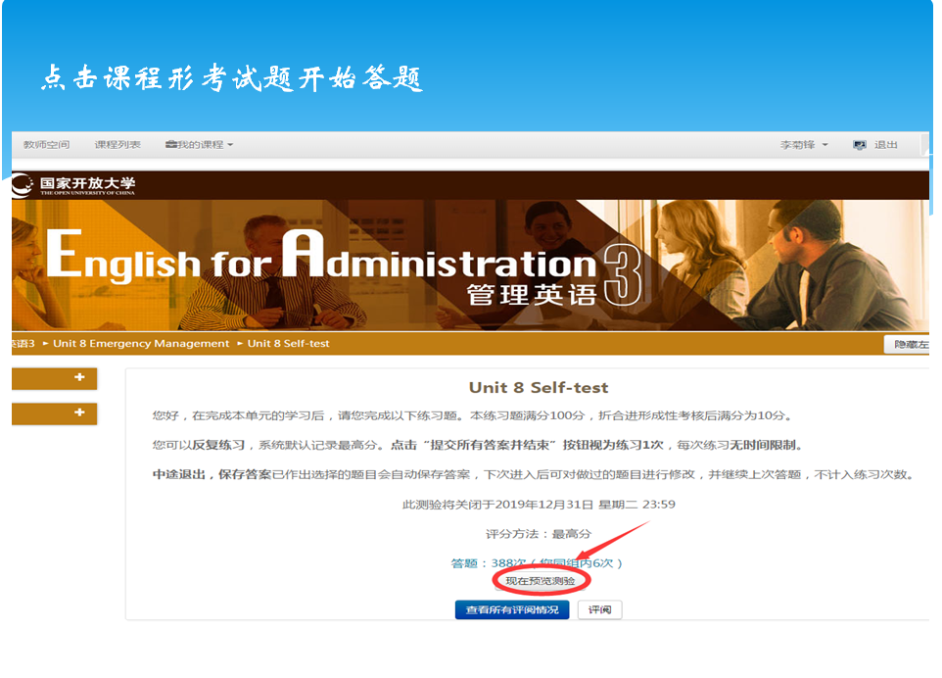

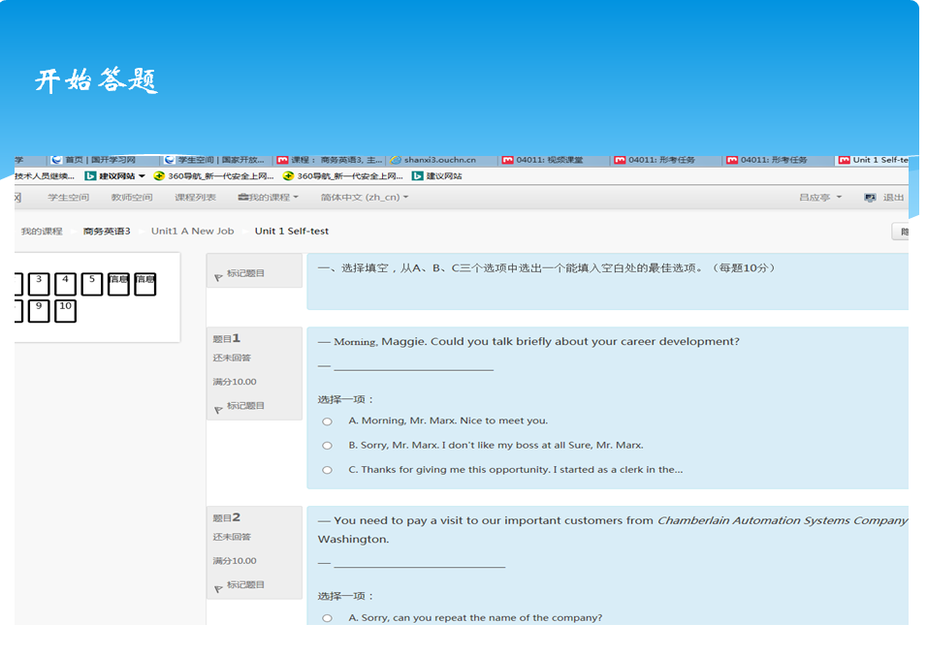

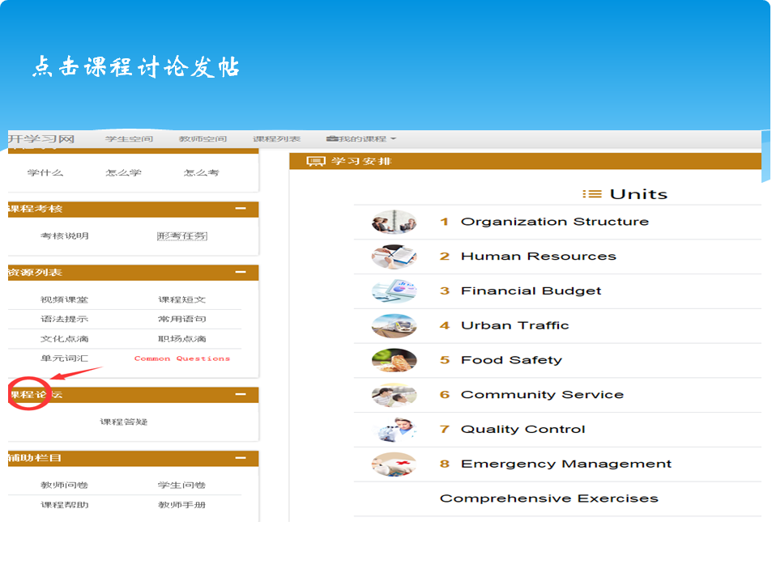

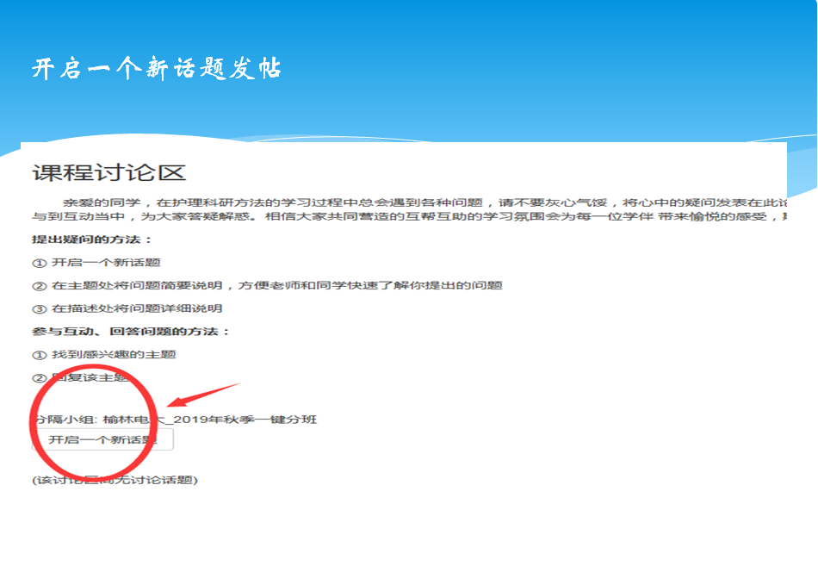

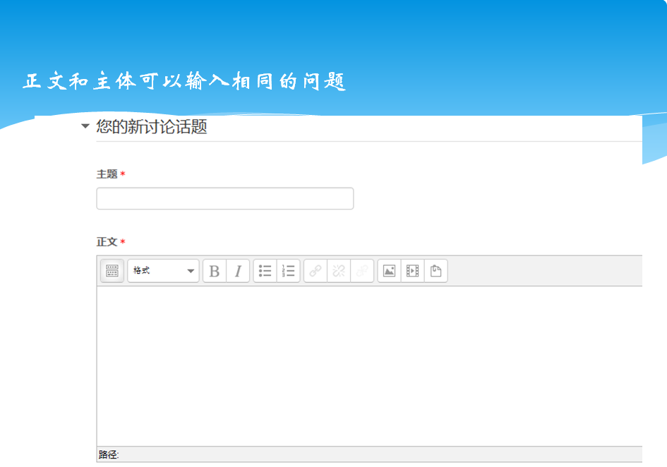

考核方式

本课程考核采用形成性考核与终结性考试相结合的方式。形成性考核占课程综合成绩的50%，终结性考试占课程综合成绩的50%。课程考核成绩统一采用百分制，即形成性考核、终结性考试、课程综合成绩均采用百分制。课程综合成绩达到60分及以上（及格），可获得本课程相应学分。

考核方式相关信息以国家开放大学当学期发布的考试安排文件为准。

**形成性考核**

形成性考核按百分制计，包括以下内容：

（1）学习单元自测 （80%）

评价方式：完成8个学习单元的自测练习并按时提交，后台会对学习任务给予实时计分，其中每个单元的自测成绩在形成性考核中各占10%。

（2）在线学习情况综合评价（20%）

评价方式：由辅导教师根据后台客观数据对学员学习情况进行综合评价，如学习资源的访问次数、在线学习时间、边学边练部分完成的情况以及课程论坛表现等情况综合评分。

**终结性考试**

考试手段：纸笔考试；考试方式：闭卷考试；考试时限：60分钟。

试题分析

管理英语3模拟试题分析

一、选择填空，从每题选项中选出一个能填入空白处的最佳选项（每题10分）。

一、选择填空，从每题选项中选出一个能填入空白处的最佳选项（每题10分）。

1、— I wish you success in your career.

—_________________

A. Go ahead.

B. It doesn't matter.

C. The same to you. 正确

2、—_______________________________

—We have three major divisions: Operations, Sales and Marketing, Finance and Administration.

A. How many departments do we have? 正确

B. Which division are you in?

C. Which department shows the best?

3、This is the man ___ last night.

A. whom I saw him

B. whom I saw 正确

C. who I saw him

4、A number of boys ____________absent some time during the term.

A. have been 正确

B. has been

C. will

5、Leave the reference books behind, __________ you won't be able to think independently.

A. or 正确

B. and

C. so

二、完型填空（每空10分）。

操作提示：通过题目中的下拉选项框选择恰当的词语补全填空。

　Joachim's vision is based on an idea called pleaching (编织), where tree branches are grown so that they naturally weave together. Since the growth patterns of trees are

by wind and sunlight, it may be possible to control the way a tree develops.

　　These Fabricated Tree House Habitats would use trees grown into shapes as housing. One of the

of these designs is that trees would not have to be cut down for lumber.

　　"A 100 percent treehouse would take years to create," Joachim said．

the climate, a house could take anywhere from 5 to 30 years to grow. Fortunately, there's a way to speed up the process. Joachim suggests including ecological materials such as sod (草皮), grasses and living branches in the housing designs. "This material would be able to move as the house grows," Joachim said．

　　A home would become an actual ecosystem, a community of plants, animals, and bacteria working together. The trees would also give off water vapor that would assist in

the homes. Solar panels and wind would help provide energy. The tree homes might even have soil pockets, where plants could grow from the structure itself.

　　Work has already begun on Joachim's first design—a house made from 50 percent recycled and 50 percent living things. Joachim is confident about the

of his work, as he uses natural products without destroying nature.

　　"The environment and its study are very important. We need to respect nature, don't take it for granted," he said．

解析：

1. 这里考查的是词义辨析，句意为植物的生长受风和阳光的“影响”。 effected引起的，affected 影响的， attempted尝试的， 所以选affected 。

2. 这里考查的是从上下文推断句意，由上文“将树木自然长成房子的形状”，显然是指这种设计的优点。所以选advantages。

3. 这里考查的是短语，根据句意，依靠自然的气候条件，要5 到30年才能长出一座房子来。depending on依靠，所以选Depending on。

4. 这里考查的是词义辨析，并根据上下文推断句意， assist in 后面要跟动名词形式，所以这道题主要是分辨选项的意思，由上文“发出水蒸气”，可得出“使房子凉爽”。 所以选cooling。

5. 这里考查的是词义辨析， 由下文他说的The environment and its study are very important可知，此处表示“他深信他工作的重要性”。 所以选importance。

管理英语3试题分析

一、选择填空，从每题选项中选出一个能填入空白处的最佳选项（每题10分）。

1、—Could I help you with your heavy box? You are so tired

— _____________ I can manage it.

A. No. thanks. 正确

B. Yes, please.

C. All right.

解析：本题考核“请求帮助”的交际用语。根据句意,说明是委婉地拒绝对方。A不，多谢；B好的，请；C好的。句意：—我可以帮你搬这个重的盒子吗？你很累！—不，多谢。我可以自己搞定。所以答案是A。

2、— Sorry, I made a mistake again.

—_________ Practise more and you’ll succeed.

A. Never mind. 正确

B. Certainly not.

C. Don't mention it.

解析： 本题考核“道歉回应”的交际用语。句意：--对不起，我又犯错了。--没关系，多练习，你会成功的。A 没关系；B当然不；C不用谢。所以答案是A。

3、The _______ was only sentenced to pay a fine of $10,000.

A. worm

B. tube

C. criminal 正确

译文：罪犯被判决罚款1万美金。

解析：worm虫子； tube管道；criminal罪犯。所以答案是C。

正确答案是：criminal

4、__________ important it is for kids to imagine freely!

A. What

B. How 正确

C. What an

译文： 让孩子自由想象是多么地重要啊！

解析：结构为“ How ＋形容词 / 副词＋主语＋谓语！”的感叹句，所以答案是B。

正确答案是：How

5、–__________ father took part in the charity activity in the neighbourhood yesterday?

– Peter's.

A. Whose 正确

B. What

C. Which

译文：-昨天谁的爸爸参加了社区的慈善活动？-皮特的爸爸。

解析：whose一般是就物主代词或名词所有格提问，疑问代词whose 后面跟名词，意为“谁的”，所以答案是A。

正确答案是：Whose

二、翻译

为下面的句子选择正确的翻译（每题10分）。

1. Though they have a lot of applicants, they can't find the people they want.

　A.虽然有很多应用，他们还是找不到他们想要的人。

　B.虽然有很多应聘者，但是他们却找不到合适的人。

　C.虽然有很多程序，但是他们却找不到合适的程序员。

2. Practising more is the key to leaning a language.

　A. 学习语言的关键是要多练习。

　B. 勤于练习就是学习英语的钥匙。

　C. 多做运动对于语言学习来说有好处。

3. Some are still nervous about losing their jobs despite the low wages.

　A. 尽管工资不高，但还是有很多人担心失去这份工作。

　B. 因为工资低，很多人打算去辞职。

　C. 尽管福利不好，但还是有很多人担心失去这份工作。

4. The teacher pointed out the grammar mistakes in the writing.

　A. 老师指出了书法里的语法错误。

　B. 老师指出了作文里的拼写错误。

　C. 老师指出了作文里的语法错误。

5. How will the evaluation of these investments be carried out?

　A. 如何进行这些项目的投资？

　B. 如何对这些投资进行评估呢？

　C. 如何对这些项目进行评价？

解析：

1. Though引导让步状语从句，“虽然……”。applicants 申请人，应聘者。所以答案是B。

2. the key to……的关键；practising 练习，训练。所以答案是A。

3. 这是一个包含despite的简单句，despite “尽管”，后面跟名词或动名词，wages “工资”，所以答案是A。

4.这是一个简单句，grammar mistakes“语法错误”， writing“写作”，所以答案是C。

5.此题中“the evaluation of these investments”的意思是“对投资的评估”；carried out实施，进行。所以答案是B。

管理英语3试题分析

一、选择填空，从每题选项中选出一个能填入空白处的最佳选项（每题10分）。

1、— Is it more advisable to upgrade our present facilities than taking the risk of opening a new park?

— ____________

A. Thank you.

B. I'm glad to hear that.

C. I don't think so. 正确

解析：本题是考核“做出判断”的交际用语, 问句是一般疑问句，答语应对问句做出判断，给予答复。A表示感谢；B表示很高兴听到某个消息，都没有做出明确答复。C表示“我不这样认为”，给出了答复。这里的so替代了前句中所说的事情，所以答案是C。

正确答案是：I don't think so.

2、— In what form will you take the investment?

— ____________

A. Yes, we will.

B. We'll contribute a site and the required premises. 正确

C. We'll give investment.

解析：该题是特殊疑问句，是对“投资方式”提问，因此答案应为具体的投资项目。A是对一般疑问句的回答；B具体回答了投资的项目为“场地和设施”，符合要求； C并没有回答相关问题。所以答案是B。

正确答案是：We'll contribute a site and the required premises.

3、They recommended that the amusement park________.

A. was extended

B. will be extended

C. be extended正确

译文：他们建议扩建那个游乐园。

解析：本题考核虚拟语气。demand (suggest, insist, desire, recommend, order, require)等表示愿望、建议、要求、命令的动词后面的宾语从句，谓语动词一般用should +动词原形，或省略 should，只用动词原形。因宾语从句的主语是amusement park，谓语动词需用被动语态，故用should + be + 过去分词，或省略should，只用be + 过去分词，所以答案是C。

4、They are trying to __________ the waste discharged by the factory for profit.

A. expose

B. exhaust

C. exploit 正确

译文：他们试图利用工厂排放的废物获利。

解析： 形近词辨析题。expose使暴露，常跟介词to连用；exhaust耗尽，使枯竭；exploit利用，开发。从句中for profit一词可以看出，这些人是想通过工厂的废物获取利润，是利用这些废物。所以答案是C。

正确答案是：exploit

5、If the building project __________ by the end of this month is delayed, the construction company will be fined.

A. to be completed 正确

B. is completed

C. being completed

译文：如果本月底应完成的工程被延期了，建筑公司会被罚款。

解析：本题考核非谓语动词作定语。if引导的条件状语从句中有谓语形式is delayed，所以空格处应该用非谓语形式作building project的定语，因为动词complete与building project之间是被动关系，而且complete的动作发生在从句谓语delay之后，是将来发生的动作，所以用不定式的被动式to be completed作定语。所以答案是A。

二、阅读理解

阅读下面的文章，根据文章内容判断文章后的句子是正确（T）还是错误（F）。（每题10分）

Save Money by Understanding Why You Spend It

　　To save money, you simply need to spend less than you earn. It is easy to say, but why is it so difficult to do? To answer this question, you need to study the factors that keep you spending all the time.

　　Easy access to credit .For most people, this is the biggest reason for overspending. People can easily get a credit card, simply by filling out a short form in a bank or jumping on their website. They can borrow money from banks to go shopping, even buy cars or houses. When you aren't physically handing someone money or a check for a purchase, you will feel you are spending free money or you aren't spending money at all. Try using cash to get your spending under control.

　　Misusing credit cards

　　A credit card is an interest free short-term loan. When used as planned, this can be a powerful financial tool. The problem is when you begin to let the balance continue from month to month. If you make a $200 purchase on your credit card and find out that at the end of the month you can't afford to repay the full amount, this is when the high interest rates on the cards really begin to hurt you. That is no way of saving money.

　　Giving in to temptation

　　We all need to enjoy life, but don't waste your financial future for a few guilty pleasures today if they aren't in your budget. When you know that you can't afford an activity, don't give in. Instead, invite your friends over for a home dinner party, game night, or some other activities where you can still enjoy time together, but without breaking your budget.

　　Spending to feel good

　　Everyone enjoys getting something new — buying yourself something feels good. There is absolutely nothing wrong with this, as long as you don't go overboard. You'll feel good about your purchase whether you make it with cash or by credit card, but you'll feel even better when you don't have to spend the next two years trying to pay it off with 20% interest.

操作提示：句子正确选择下拉选项框为“T”；句子错误选择下拉选项框为“F”。

1. For most people, easy access to credit is the biggest reason for overspending.

2. You have to pay for the credit card loans by the end of each month.

3. Using a credit card to pay is spending free money. 4. Getting credit cards from various banks and using the overdraft to the limit can help you “spend to feel good”.

5. Always pay attention to your budget while spending.

解析：

1. 此题考核句子中“this”所指代的内容。 此题信息对应文章第二部分标题内容和第一段主题句内容的衔接。对应的部分为标题“Easy access to credit”，主题句为“For most people, this is the biggest reason for overspending”。“this”所指代的内容是“Easy access to credit”，所以选T。

2. 这是一道推断题，按照常识推断，信用卡借款每月必须偿还，所以选T。

3. 这是一道推断题，按照常识判断，使用银行的信用卡付款，需在月末偿还借款，而非“spending free money”，此处指“不用还款”。所以选F。

4. 这是一道细节题，结合上下文，做到“spend to feel good”即“安心支付”不能“透支使用”所以选F。

5. 这是一道推断题，结合上下文，本句是对全文的总结，得出的结论。做到“日常支出应做好预算”。所以选T。

管理英语3试题分析

一、选择填空，从每题选项中选出一个能填入空白处的最佳选项（每题10分）。

1、— How did you miss your train?、

—____________________

A. Well, I was caught in the traffic jam. 正确

B. What's your proposal?

C. Never mind.

解析：本题考核“交通与出行”的交际用语。How did you miss your train? 询问对方“为什么错过了火车”，答语是“塞车了”，所以答案是A。

正确答案是：Well, I was caught in the traffic jam.

2、— I'm dog tired. I can't walk any further, Tommy.

— ______, Jenny. You can do it.

A. No problem

B. Come on 正确

C. No hurry

解析：本题考核“加油鼓励”的交际用语。Come on是“鼓励”用语。No problem没问题；No hurry不用急，慢慢来。这里是“加油鼓励”的意思, 所以答案是B。

正确答案是：Come on

3、I bought a new car last month, but I ______ my old car yet.

A. did not sell

B. have not sold 正确

C. had not sold

反馈

你的回答正确

译文：上个月我买了一辆新车，但旧车还没卖掉。

解析： 并列句前面一个分句因为有时间状语last month，用了一般过去时，但后面的分句用了yet，要求用现在完成时，所以答案是B。

正确答案是：have not sold

4、I ______ to know how often the bus runs during rush hour.

A. occur

B. happen正确

C. take place

解析：考查同义词/词组的辨析。虽然三个选项都有“发生”的意思，但happen to do...可用于固定搭配，意为“碰巧，恰好”，所以答案是B。

正确答案是：happen

5、— When do we have to pay the bill?

—____ December 30.

A. By正确

B. In

C. During

解析：考查介词的用法区别。表示“到……为止”要用介词by，不用in；during要接表示阶段的名词。根据语境，所以答案是A。

二、阅读理解

阅读下面的文章，根据文章内容，完成相应的选择题。（每题10分）

Beijing's Roads for the Future

　　The road system in Beijing's central business district (CBD) is being re-designed to make public transportation easy and improve efficiency.

　　Plans for 45 roads within the CBD have been approved, measuring 41.5 kilometers in total. In addition to public buses, free or low price shuttle buses from residence areas to subway stations will also be provided for commuters.

　　This is just over four times the number of roads opened in 2007, and will add another 15.5 km to the existing road network.

　　Besides roads, an underground traffic system has also been operating, which includes four new subway lines beneath the CBD.

　　The underground connection system is made up of two levels. The first underground floor is set aside mainly for pedestrians and commercial facilities, while the second underground floor is planned for parking.

　　The city has also invested 140 million yuan to set up a traffic inquiry system, through which the public can check traffic conditions online and see the most convenient routes on their GPS system. In the future, the CBD will be fully covered by an intelligent traffic control system.

操作提示：通过题干后的下拉框选择题目的正确答案。

1. The road system in Beijing's downtown area is being to make public transportation easy and improve efficiency. 回答正确

　A. built

　B. designed again

　C. constructed

2. An underground system including new subway lines beneath the CBD has been operating. 回答正确

　A. 2

　B. 3

　C. 4

3. The underground connection system consists of _____ level(s). 回答正确

　A. one

　B. two

　C. three

4. CBD stands for _____. 回答正确

　A. Central Business District

　B. Convention on Biological Diversity

　C. Chemistry and Biomedical Engineering

5. Beijing has set up _______ for people to check traffic conditions.

　A. traffic lights

　B. underground floor

　C. a traffic inquiry system

正确答案 BCBAC

管理英语3试题分析

一、选择填空，从每题选项中选出一个能填入空白处的最佳选项（每题10分）。

1、—What do you think about Japanese food?

—____________________

A. Overall, the diet there is a healthy one-- low fat. 正确

B. Public environment has been greatly improved.

C. I didn't have much time to prepare food, so I ate out a lot.

解析：本题考核“食物”的交际用语。根据问句“你觉得日本的食物怎样？”，答句“总的来说，那儿的饮食脂肪低比较健康”。选项B回答是公共环境改善，选项C是回答没时间做饭，常上馆子，答非所问，所以答案是A。

正确答案是：Overall, the diet there is a healthy one-- low fat.

2、— Do you mind if I smoke here?

—__________________

A. No, thanks.

B. Yes, please.

C. Yes, better not. 正确

解析：本题考核“是否介意”的交际用语。mind 介意，回答“介意”要用yes,“不介意”要用no, 前后要一致，所以答案是C。

正确答案是：Yes, better not.

3、— Does she speak French or German?

— She doesn't, _____.

A. either 正确

B. neither

C. none

译文：“她说法语还是德语？”“她哪一种都不会说。”

解析：句子的意思是“他哪一种都不会”。在这个句子里是对并列的两个事物的分别否定，由于后者回答的句子中已经有助动词does的否定形式doesn't，所以用either即not......either相当于neither。none指三个以上一个也没有，与句意和语法要求都不相符。所以答案是A。

4、A vegetarian diet consists of the following EXCEPT ___________.

A. meat 正确

B. vegetable

C. fruit

5、I ________ a book when the telephone______.

A. was reading…rang正确

B. read…rang

C. was reading…was ringing

译文： 我正在看书，突然电话铃响了。

解析：本题的主句用的是过去进行时，表示持续进行中的动作，when引导的时间状语从句用一般过去时，表示在主句持续动作期间发生的短暂动作。所以答案是A。

正确答案是：was reading…rang

二、完型填空（每空10分）。

操作提示：通过题目中的下拉选项框选择恰当的词语补全填空。

　　Fruit is good for people. Many people eat some

every day. Mr. Black and Mrs. Black like fruit very much and every Monday Mrs. Black goes to buy some fruit in the shop near her house. The man in the shop knows her well and helps a lot. She can buy all

of fruit there, like apples, pears, oranges and bananas. In different time of the year the

of each kind of fruit is not the

, sometimes high, something low. Mrs. Black likes to buy cheap fruit. But Mr. Black likes bananas only. She buys bananas for him every week. She only buys cheap

for herself.

解析：

1. 尽管答案B和C都是水果，但都是指某种水果，而答案A包含了各种水果，含义更全面，也正好与前一句呼应。Some一词既可以修饰单数名词，也可以修饰复数名词。fruit 当于集合名词，无须加s。所以选fruit 。

2. 这里需要的是表示种类的量词，表示各种各样的词组是all kinds of，这是固定搭配。所以选kinds。

3. 空缺处后边起后置定语作用的介词短语中有明确表示单数性质的each，因此从语言逻辑上看，被它修饰的名词也应该是单数的。根据句意，这里应该指价格，而不是答案C所说的“价值”。 所以选price。

4. 前边已经提到“在一年的不同时间里”，也提到了价格，该空缺处前边又有否定词not，逻辑关系决定需要选“same”，其他几个答案无法满足这一关系，且语义不通。所以选same。

5. 根据上下文的关系，这里还是应该指水果而不是其他。 答案B和C都是泛指的“货物”和“产品”，范围更广，无法和前一句具体谈及的东西形成比较关系。所以选fruit。

管理英语3试题分析

一、选择填空，从每题选项中选出一个能填入空白处的最佳选项（每题10分）。

1、—Anything else?

—________________

A. We provide education relating to depression and anxiety.

B. First, we provide education relating to depression and anxiety.

C. Moreover, we provide education relating to depression and anxiety. 正确

解析：本题考核“列举”的交际用语。first，then，finally，moreover等词语常用来表达列举、做事的步骤。根据第一说话人包含的信息，列举的事件已经不是第一个，所以答案是C。

正确答案是：Moreover, we provide education relating to depression and anxiety.

2、— ___________________

— Once or twice a week.

A. How soon will you arrange for me to visit someone at home?

B. How often will you arrange for me to visit someone at home? 正确

C. How long will you arrange for me to visit someone at home?

解析：本题考核“确定频率”的交际用语。how soon, how often, how long都可译作“多久”，但how long用来提问“一段时间的长短”；how soon用来提问“过多少时间（就能……）”；how often用来提问某动作发生的频率；根据答语“每周一到二次”，所以答案是B。

正确答案是：How often will you arrange for me to visit someone at home?

3、Business people exercise their leadership in the community service area ______ the commercial world.

A. as well as 正确

B. but

C. so

译文：商务人士不仅在商业界发挥领导才能，在社区服务领域也同样如此。

解析：as well as常用来连接两个并列的成分，表示“也，还”，根据句意，所以答案是A。

正确答案是：as well as

4、The online What's on for Women provides information ______ upcoming and ongoing events.

A. about 正确

B. for

C. with

译文：在线“女性之声”栏目提供有关正在或即将进行的活动的相关信息。

解析： provide及物动词，提供；information 信息，后跟about, 表示“与……相关的信息”，所以答案是A。

正确答案是：about

5、One of the main benefits of community service is that it ______ a person's character.

A. sets

B. builds 正确

C. makes

译文：社区服务的主要好处之一是它可以塑造一个人的性格。

解析： character性格，个性。根据句意，需选择一个能表达“塑造，影响，决定”的动词，build有此意，所以答案是B。

正确答案是：builds

二、听力理解

听对话录音，根据对话内容完成下方题目（每题10分）。

操作提示：通过每题的下拉框选择题目的正确答案。

1. What are health care programs mainly about? 回答正确

2. What is the first part of community service health? 回答正确

3. How can people help themselves avoid illness? 回答正确

4. What areas are of growing concern? 回答正确

5. Who typically provides bedside care? 回答正确

管理英语3试题分析

一、选择填空，从每题选项中选出一个能填入空白处的最佳选项（每题10分）。

1、—________________ about it now?

—Every time a customer has complained we've followed our store policy and offered them an exchange or a full refund.

A. What's the plan

B. What's be doing

C. What's being done 正确

解析：本题考核“问询工作进展”的交际用语。根据答语的现在完成时态推断问题是关于目前已经做了哪些工作。A是一般现在时； B为现在进行时； C为现在完成进行时，表示行动已经开始并将持续进行，所以答案是C。

正确答案是：What's being done

2、—What's the latest situation with all these customer complaints we've been receiving?

—___________the quality of the material has not always been up to standard.

A. I believe

B. I'm afraid 正确

C. I think

解析：本题考核“委婉陈述事实”的交际用语。I'm afraid…常用于引领陈述不太理想或与预期不符的事实。根据第一说话人关于customer complaints的提问和回答中所包含的否定的信息，确定此处回答并不是说话人的主观推断，而是基于事实的一个回答，所以答案是B。

3、Our new school building is __________ construction.

A. under正确

B. in

C. having

解析：短语under construction 为固定搭配，意为在建设中，in和having都不是正确的搭配，所以答案是A。

正确答案是：under

4、Proper controls that should ________________ developed as part of routine safety procedures were not in place.

A. has been

B. have been 正确

C. be

译文：本该制定的作为部分日常安全程序的正确管控措施没有到位。

解析：此处应使用虚拟语气的被动语态形式，“should have +过去分词” 表示与过去事实相反，预期发生，但实际上并未发生，所以正确是C。

正确答案是：have been

5、I'm going to have a ________ with Mark about this issue tomorrow.

A. speech

B. sentence

C. word正确

译文：关于这件事明天我打算和马克谈一谈。

解析：动词短语have a word with sb意为“跟某人谈谈”； A是演讲的意思，发表一次演说常用表述为give a speech，B为错误的搭配，英语中没有have a sentence with sb这样的表达。所以答案是C。

正确答案是：word

二、听力理解

听对话录音，根据对话内容完成下方题目（每题10分）。

操作提示：通过题干后的下拉框选择题目的正确答案。

1. What is the product they are talking about?

　A. Skirts.

　B. Shirts.

　C. Materials.

2. What is the problem with the product?

　A. Quality.

　B. Color.

　C. Quantity.

3. Who first finds out the problem?

　A. The supplier.

　B. The customer.

　C. The store.

4. Who first receives the customer's complaints?

　A. The supplier.

　B. The manager.

　C. The store.

5. What is the source of the problem?

　A. The purchasing department.

　B. The store.

　C. The supplier.

正确答案 ：CABBA

管理英语3试题分析

一、选择填空，从每题选项中选出一个能填入空白处的最佳选项（每题10分）。

1、—_____________________

— Fire, fire service please! There's a huge fire here.

A. 911, how may I direct your call? 正确

B. How may I help you?

C. What can I do for you?

解析：本题考核“表达提供帮助”的交际用语。How may I help you? 常用于服务性行业，询问对方“是否需要帮助”，答语一般使用I need…/I'd like to等句型表达需求。根据第二说话人包含的信息，确定这是发生火灾，人们请求援助的电话，所以答案是A。

正确答案是：911, how may I direct your call?

2、—__________________

— With pleasure. Emergency planning covers several different aspects.

A. Could you explain when your work on emergency planning began?

B. Could you explain why your work on emergency planning is still on?

C. Could you explain how your work on emergency planning is going on? 正确

解析：本题考核“作解释”的交际用语。A是询问何时开始制定应急计划的， B是询问应急计划制定未完成的原因， C是询问应急计划的进展。根据答语“应急计划涵盖不同的方面内容”，确定这里是询问正在制定的应急计划的进展，所以答案是C。

正确答案是：Could you explain how your work on emergency planning is going on?

3、Chemical spill guidelines should be established by the lab supervisor and should take into ______ the following.

A. consideration 正确

B. confidence

C. care

译文：化学品泄漏的管理准则应该由实验室主管制定，并且应考虑以下内容。

解析：三个选项都能与take into 连用，构成固定搭配，take into consideration考虑；take into confidence向（某人）透露自己的心事，将秘密告诉（某人）；take into care（儿童）由收养所（或其他家庭）收养。根据语境，应选择词意“考虑”，所以答案是A。

正确答案是：consideration

4、Some of the risks may be relevant to your community. Find out which ones by ______ www.GetPrepared.uk.

A. visiting 正确

B. visit

C. visited

译文：有些危险情况可能涉及到您所在的社区。请通过访问www.GetPrepared.uk.网址进 行查看。

解析：此句为介词by引导方式状语的简单句，后接名词或动名词，所以答案是A。

正确答案是：visiting

5、These preparedness frameworks either exist in various stages of development ______ have been implemented.

选择一项：

A. nor

B. and

C. or 正确

译文：这些应急准备体系有的存在于不同的发展时期，有的已经付诸实施。

解析：此句中已经含either，固定搭配为either…or，意为“或者……或者”，表示两者之一，连接句子中两个并列的成分，所以答案是C。

正确答案是：or

二、阅读理解

阅读下面的文章，根据文章内容，完成相应的选择题。（每题10分）

Ebola Surge — 2014

　　The 2014 Ebola outbreak is the largest in history and the first Ebola outbreak in West Africa. Although the current epidemic does not cause a significant risk to other nations, many countries, including China and the United States of America, have actually been working closely with the Ebola hit states. For example, the US Centers for Disease Control and Prevention (CDC) is taking precautions at home besides its activities abroad.

　　CDC's team of “virus hunters” is supported by specialized public health teams both in West Africa and at the CDC Atlanta headquarters. Together, they offer continuous support to save lives and protect people. CDC works closely with a number of US government agencies, national and international partners. CDC's experience of working with Ebola is important to the World Health Organization's growing West Africa Ebola response.

　　On Sept. 2, 2014, CDC Director, Tom Frieden called for more international partners to join this effort. “The sooner the world comes together to help West Africa, the safer we all will be. We know how to stop this outbreak. There is a window of opportunity to do so — the challenge is to scale up the massive response needed to stop this outbreak.”

　　CDC's response to Ebola is the largest international outbreak response in CDC's history with over 100 disease specialists on the ground in West Africa, supported by hundreds of public health emergency response experts stateside, activated at Level 1, its highest level, because of the significance of this outbreak.

　　The CDC supports affected countries to establish Emergency Operations Centers at national and local levels and helps countries track the epidemic including using real-time data to improve realtime response.

　　Efforts in West Africa to identify those infected and track people who have come into contact with them are improving. The CDC is operating and supporting labs in the region to improve diagnosis and testing samples from people with suspected Ebola from around the world.

　　Local health care systems are strengthened through communication, coordination with partners and training on infection control for health care workers and safe patient treatment.

操作提示：通过题干后的下拉框选择题目的正确答案。

1. How could we describe the 2014 Ebola outbreak?

　A. The first one in western countries.

　B. It did not ever threaten West Africa.

　C. Not the first but the largest one.

2. The 2014 Ebola outbreak response was.　A. an American stateside activity

　B. an international activity

　C. a regional activity

3. What does the word “massive” mean in Para. 3?　A. Huge.

　B. Quick.

　C. Urgent.

4. How many disease specialists from CDC have gone to West Africa for the Ebola response?

　A. Less than 100.

　B. A hundred.

　C. More than 100.

5. What action does CDC take to respond to the large Ebola outbreak?　A. Work closely with governmental, national and international partners.

　B. Call for more partners to join this effort.

　C. Establish Emergency Operations Centers.

解析：

1.这是一道细节题。本题询问“如何描述2014年的埃博拉病毒爆发”。此题信息对应文章第一段的第一句话The 2014 Ebola outbreak is the largest in history and the first Ebola outbreak in West Africa，所以选C。

2.这是一道细节题。本题询问“2014埃博拉病毒爆发的应急反应是怎样的”。此题信息对应文章第一段里多国参与抗击埃博拉，many countries, including China and the United States of America, have actually been working closely with the Ebola hit states，所以选B。

3.这是一道词义辨析题。本题询问“massive”的含义，首先从构词法的角度来看，massive由mass派生而来，其次后缀ive表示“拥有…的性质；有…的倾向；与…相关”，所以选A。

4.这是一道细节题。本题询问“共有多少美国疾病控制中心的专家亲临西非参与抗击埃博拉病毒”。此题信息对应文章的第四段，over 100 disease specialists on the ground in West Africa，所以选C。

5.这是一道归纳题。本题询问“美国疾病控制中心在应对埃博拉疫情爆发的行动中采取了什么措施”。文章第三段提到“呼吁更多国际合作者参与此次抗击埃博拉”，文章第五段提到“CDC支助受感染的国家建立应急处理中心”，故此题信息对应文章的第二段，CDC works closely with a number of U.S. government agencies, national and international partners，所以选A。

